PARAGON - INNOVATING THE WAY AGENTS DO BUSINESS
Paragon Release 5.90

We (enter your MLS Name here) wanted you to be the first to know about the latest enhancements to your Paragon MLS System. All enhancements are designed to help you navigate through the system and enhance your experience with Paragon. Below is a list of the enhancements and links to view videos or PDFs of the new features. We encourage you to continue reading and let us know what you think on the Paragon MLS Facebook site. Also make sure you click “Like” on the Facebook site to view what’s new with Paragon more frequently.

WHAT’S NEW!

PARAGON
- NAR Mandate – Broker Attribution

In compliance with the NAR mandate for Broker Attribution, a new node has been added to the Preferences/System tree for “IDX/VOW Contact Info” in Paragon Professional. This addition will allow the broker to select a phone number or email address to be displayed in listings that go out in IDX and VOW data feeds via RETS.
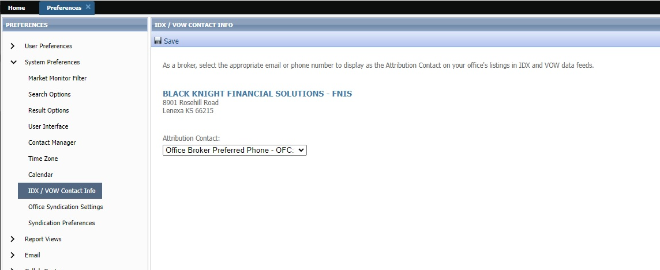
Figure 1: IDX/VOW Contact Info node

A dropdown will be added to the page labeled as ‘Attribution Contact,’ thus allowing the broker to select from a list of phone numbers and emails. However, this field is optional, and the broker does not have to set a value. Only security level 5 and up will be able to populate this field and only one value can be selected. The dropdown list will include the following options:
- No value selected
- Agent preferred phone
- Agent email
- Office broker preferred phone
- Office broker email
- Office phone #1 – 3
- Office email

When any of the above options are not populated with data in Paragon, that option will not display in the dropdown list. If a broker is not assigned to the office, a message will appear indicating, “No broker is currently assigned to this office” and the two broker dropdown options will not appear in the list.
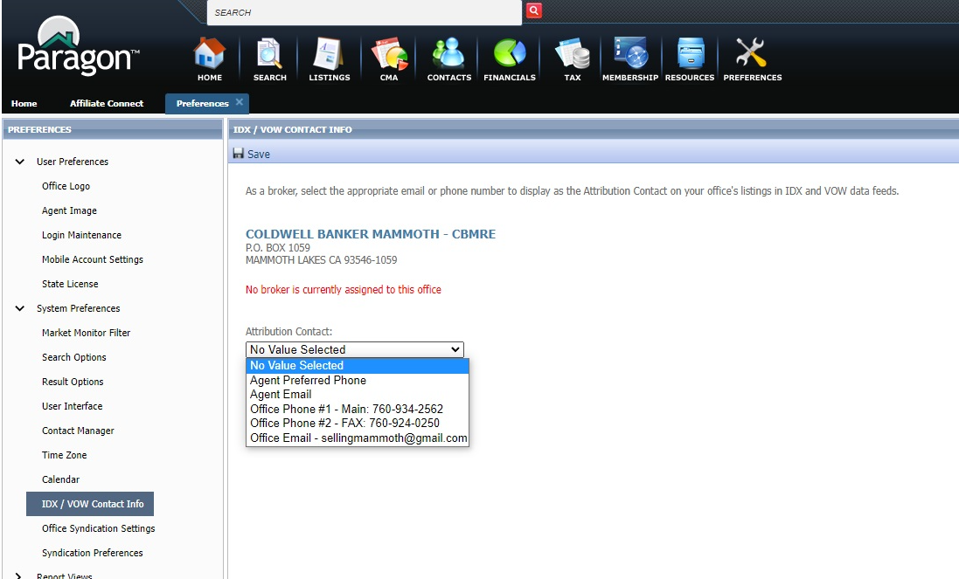 Figure 2: No broker associated with the office

When the broker is assigned to multiple offices, each office will appear with a separate dropdown. The broker will have the ability to set a different value for each office. 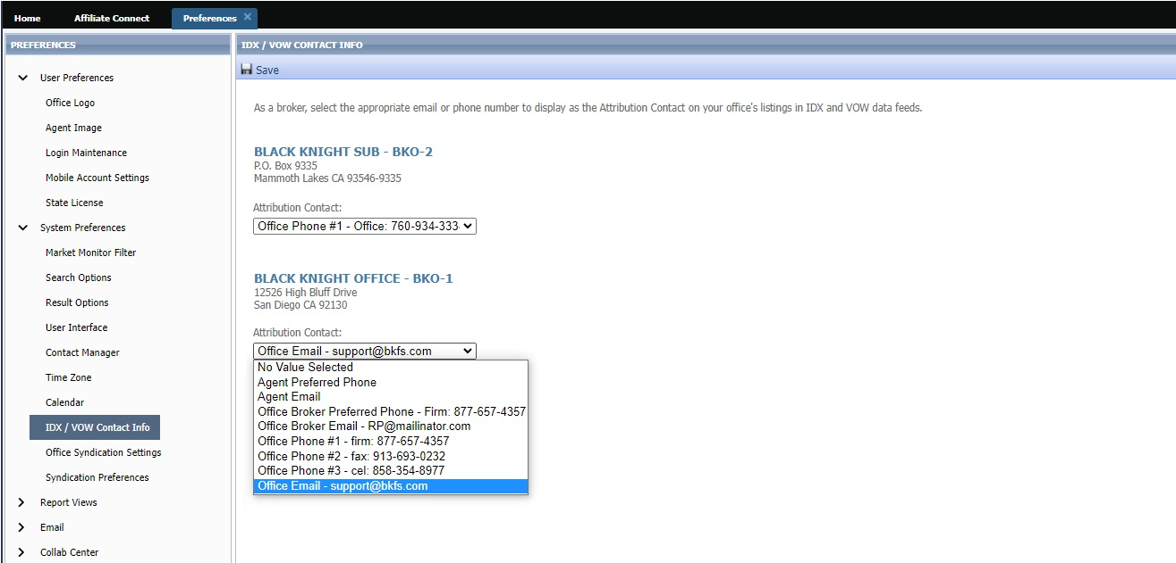
Figure 3: Multiple offices

The “No Value Selected,” which is equivalent to not having selected an option, will be the default. As per the mandate, the Listing Participant must select the value and therefore, Black Knight is not allowed to pre-select for the Broker/MLS. Once a real value is selected by the broker, the actual phone number or email address will get appended to outbound IDX and VOW listing data feeds. The field will be labeled as, ‘AttributionContact’ in the data feed in accordance with the RESO standard. Also, a RETS Profile will need to be created for the Attribution Contact.

When any of the above options are not populated with data in Paragon, that option will not display in the dropdown list. If a broker is not assigned to the office, a message will appear indicating, “No broker is currently assigned to this office” and the two broker dropdown options will not appear in the list.

- Statistical Reporting – Add Zero Volume filter to Year-to-Year Report

The Year-to-Year report now respects the Include with Zero Volume filter. When selected, the report includes all results. When unselected, the report will exclude sections where all columns are zeroes.
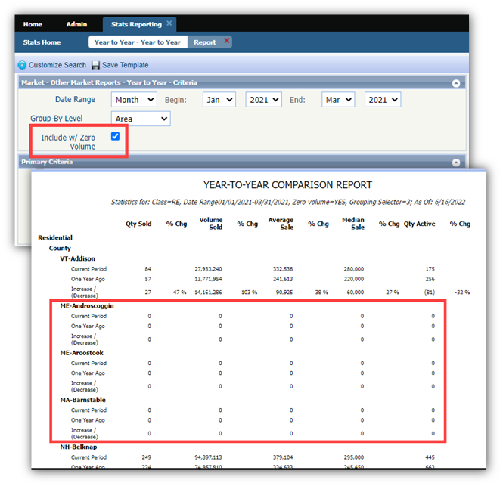
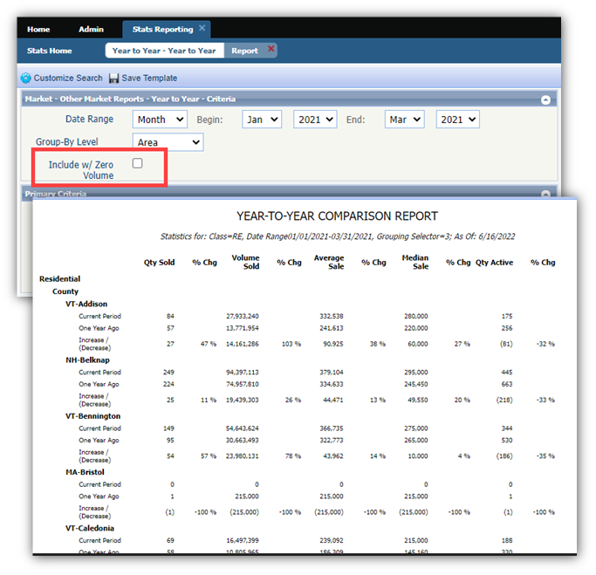
Please note: If your association/MLS has turned this feature on, you will be able to use this function.

- Statistical Reporting – Enhance Month End Report to use location filters

The Month End statistical report now respects any location filters selected in the Primary Criteria container. Previously, locations could be added but the report only returned results for all locations.
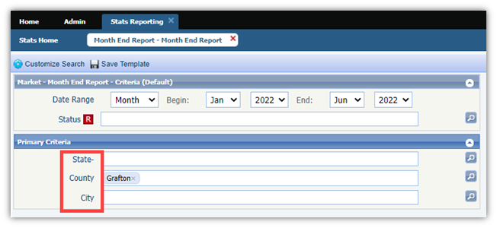
Please note: If your association/MLS has turned this feature on, you will be able to use this function.

Collaboration Center

- Removal of Show Community Report Button
Previously, CollabLink and Collab Center displayed a SHOW COMMUNITY REPORT. Consumers would have to click the button to view the report. The button has been removed and the report will automatically display when the user clicks the COMMUNITY REPORTS tab OR scrolls to the bottom of the detail view.
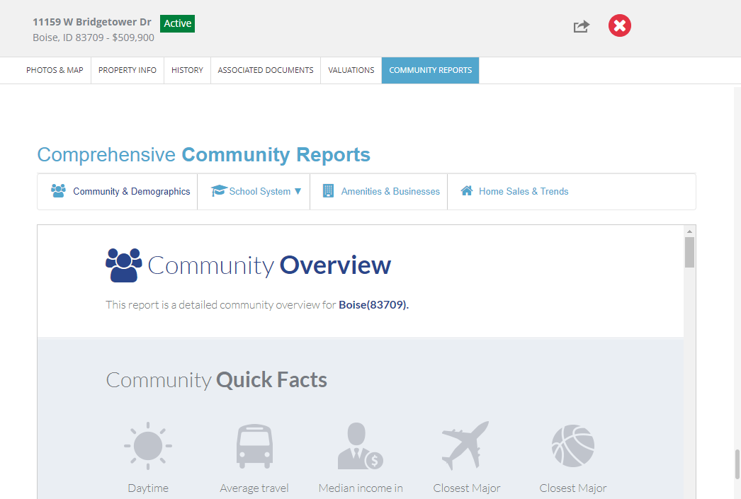
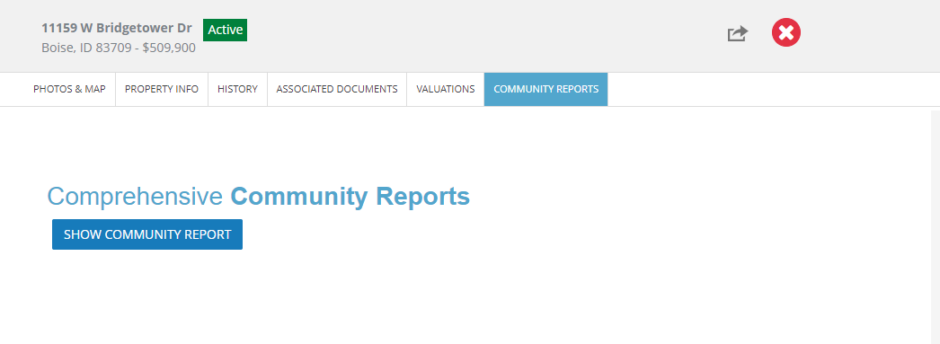
Paragon Connect

- New Hotsheet
The Hotsheet search in Paragon Connect has been completely remodeled and upgraded in the 5.90 release. This search now includes additional functionality that makes it fully in sync with Paragon Professional. In addition to the new functionality, this module has been migrated into our React/Inferno code base. It even includes a few new features not found in Paragon Professional. Below are some highlights of the new Hotsheet search.
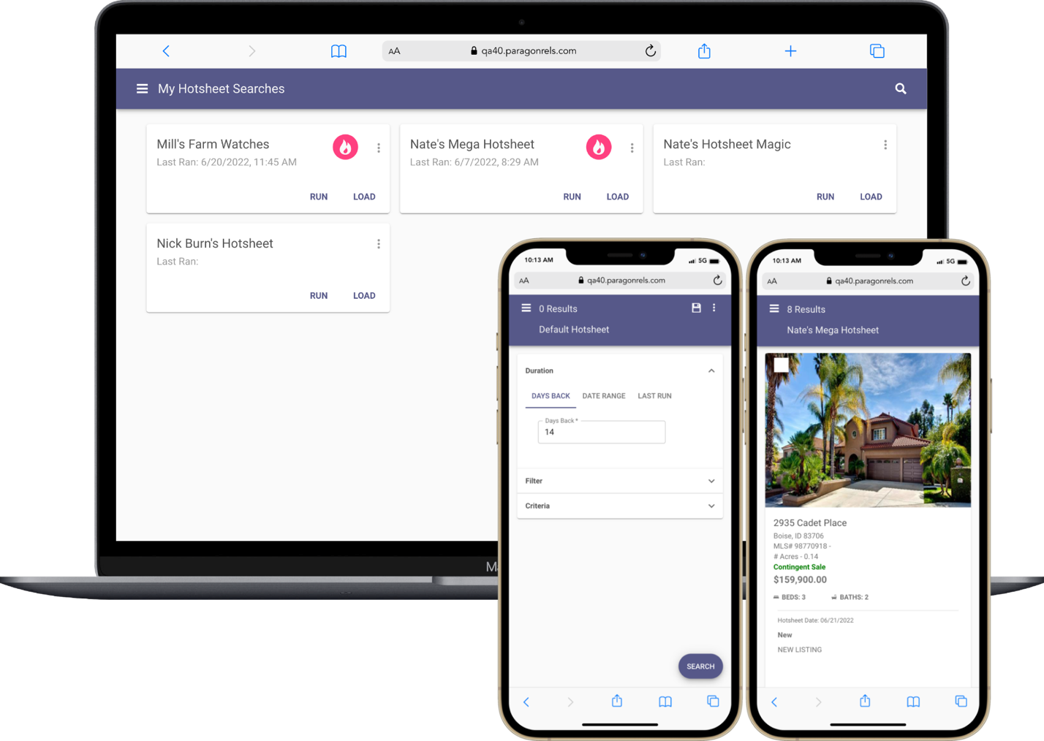

- Hotsheet Duration
Prior to the 5.90 release, the Hotsheet search in Paragon Connect only allowed you to use a date range to locate hotsheet records. Now you have three separate duration options.

Days Back:
The days back control allows you to quickly search for previous days in the past. The control allows you to search up to 999 days in the past and only accepts numeric values. It is the first option found on the form.

Date Range:
A new date range component has been implemented on the Hotsheet search. Like the previous version, an agent can manually type a begin and end date. However, the new component also allows you to use an advance operator to choose from MLS defined time frames. You can also use a calendar control to select a begin and end date.

Last Run:
The last run option allows an agent to run a search based on the last time that Hotsheet was ran. This is also slightly different from how Paragon Pro functions. Paragon Pro will use the last run date regardless of the search loaded. Whereas Paragon Connect will track the last run date for each Hotsheet search.
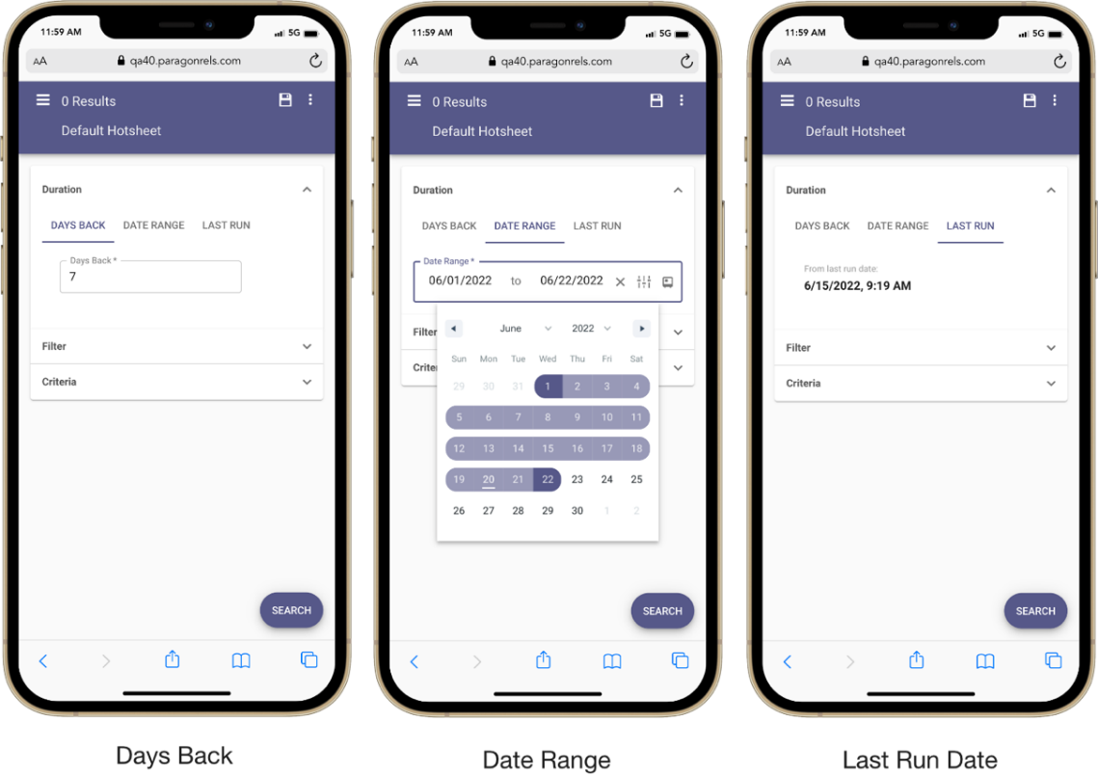

- Hotsheet Filter
The filter container consists of a list of Hotsheet types and statuses. These are the same types and statuses found in Paragon Pro. This allows the agent to filter on specific types of hotsheet records.

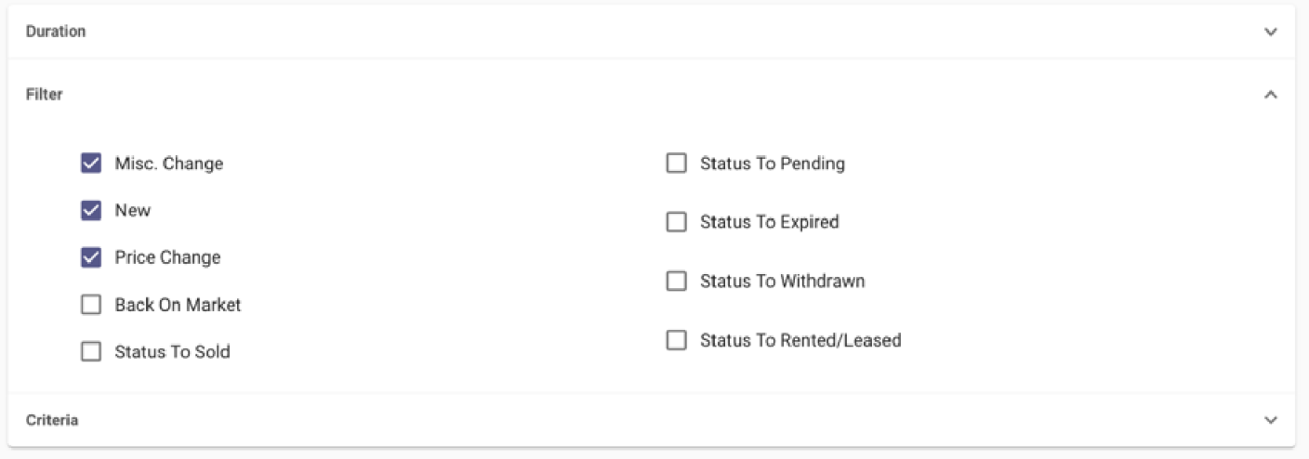

- Hotsheet Criteria
You will find up to sixteen additional MLS defined fields in the “Criteria” container. These are the same fields used in your Paragon Pro system. This provides you with even more filtering capabilities. It is like building your own market monitor.

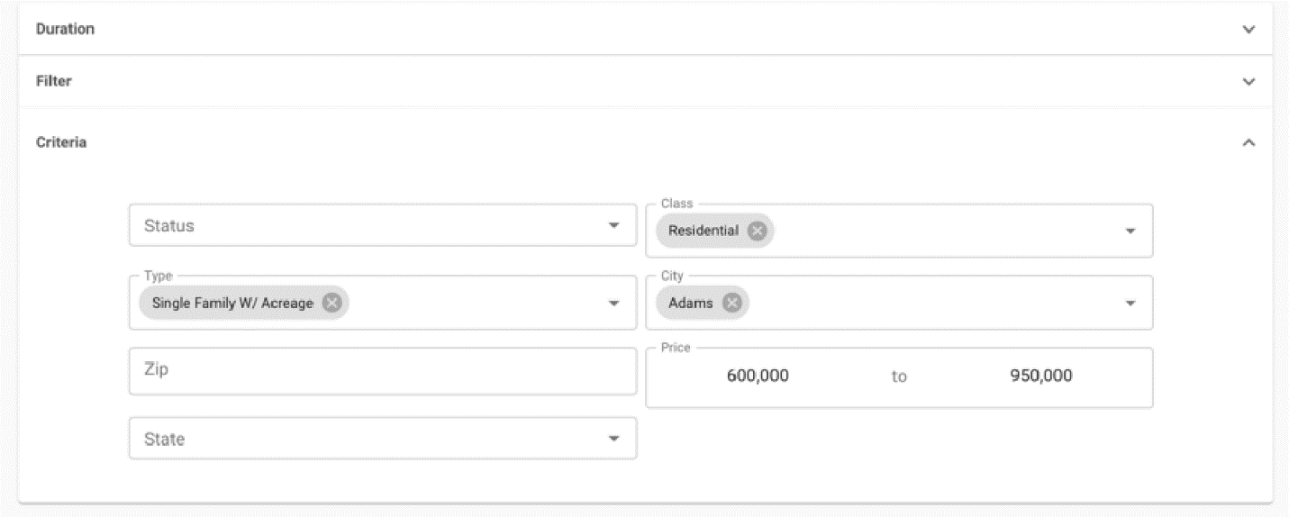

- Hotsheet Results
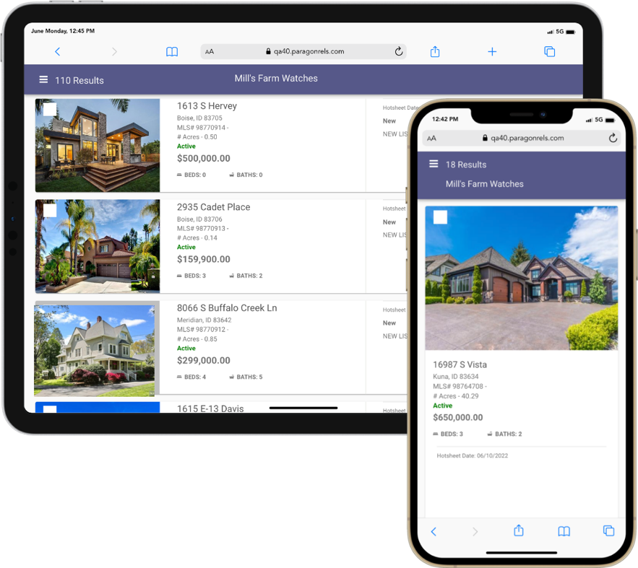
The Hotsheet thumbnail results has been updated to include Hotsheet update date, status/type, and any Hotsheet comments made.
The search results utilize the latest React/Inferno code, allowing for faster response times. In addition, the 500-listing limit is not applied to the hotsheet search
Just like any result in the system, you can select one or more listings and choose to share via email, text, copy link, Facebook, Twitter etc. You can also add listings to a cart, get driving directions, or even access any third-party integration.

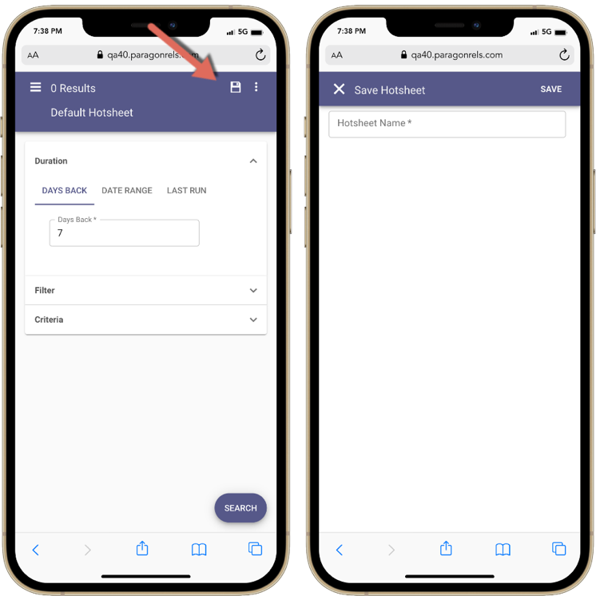
- Save Hotsheet Search
The ability to save a Hotsheet has been added in the 5.90 release. Once created, these hotsheet searches can be found and edited in Paragon Pro and vice versa.
To save a Hotsheet search you just tap on the save icon. If you are on the default Hotsheet template, taping save will create a new Hotsheet search. If you load a Hotsheet, taping save will just save any changes you made to the Hotsheet.

- Hotsheet Update Default Template
In addition to saving a Hotsheet, agents can also update their default Hotsheet template. This allows you to retain the criteria you want each time you load the Hotsheet search module.
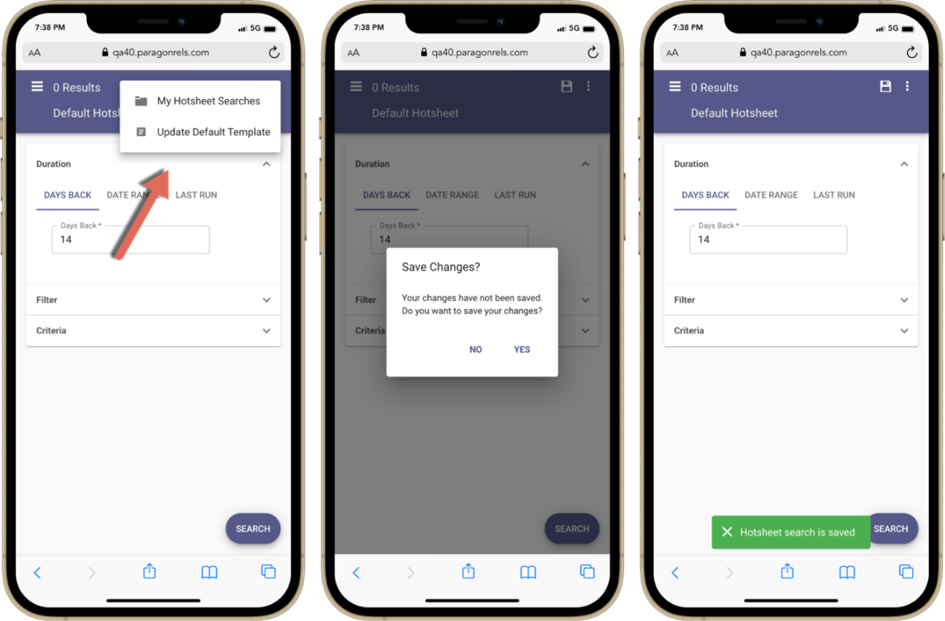
To update the template, make your changes to the form, then from the overflow menu (three dots) tap on “Update Default Template.” After you confirm this request, your Hotsheet will load with your new default criteria.

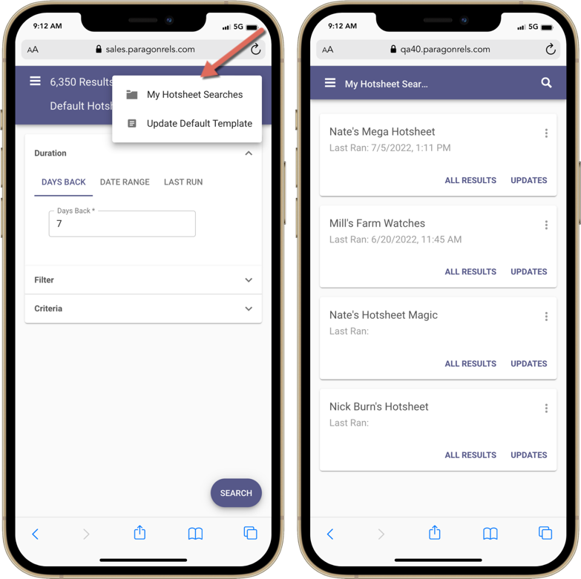
- Load Hotsheet
So far, we know you can update their default template and save hotsheet searches. Now we will look at how you can load a Hotsheet search.
To load a Hotsheet search, you must tap on the overflow (three dot) icon on the top app bar. From the drop-down menu that appears, tap “My Hotsheet Searches.” The system will respond by opening a page with saved Hotsheet cards.
Each Hotsheet is ordered by the last time it was ran. The cards also contain two links.

All Results:
This allows you to view all hotsheet records found based on the hotsheet criteria you entered.

Updates:
This will only return hotsheet results since you last ran this hotsheet search.

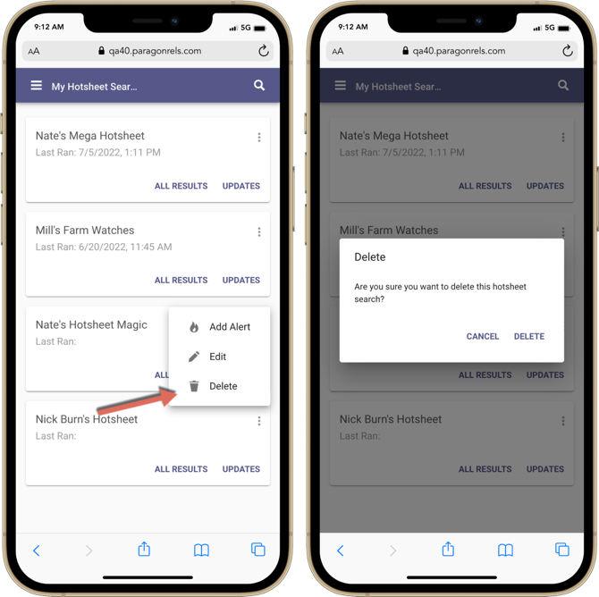
- Delete Hotsheet
Over time you may decide you no longer need a saved hotsheet. Good news, in Paragon Connect, you can now delete saved hotsheets. To delete, you just need to tap “Delete” from the overflow menu found on each saved hotsheet card. Once you confirm the request, the hotsheet saved search is removed from the system and all other cards move up in the order.

- Hotsheet Alerts
Hotsheet Alerts is a brand-new feature only found in Paragon Connect. It allows you to get notified when new matches are found based since the last time your hotsheet search was ran. You can enable alerts for up to five hotsheets.

Adding Alert:
To add an alert, you just need to tap on the overflow icon (three dots) on any saved Hotsheet search. From there you just tap on “Add Alert.” This will add a new pink icon on the card indicating an alert has been added.

Removing Alert:
You can also remove an alert from a saved Hotsheet. Just like when you added an alert, you will tap on the overflow menu on the hotsheet saved card and choose “Remove Alert.” This will remove the alert and the pink fire icon on the card.
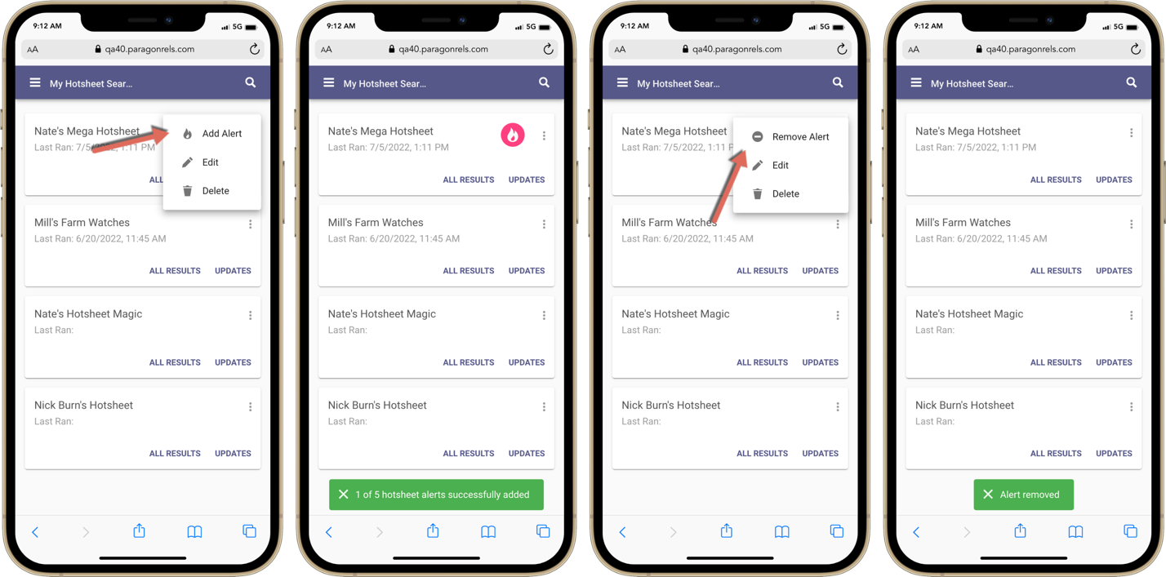

- Homepage Alerts for Hotsheet
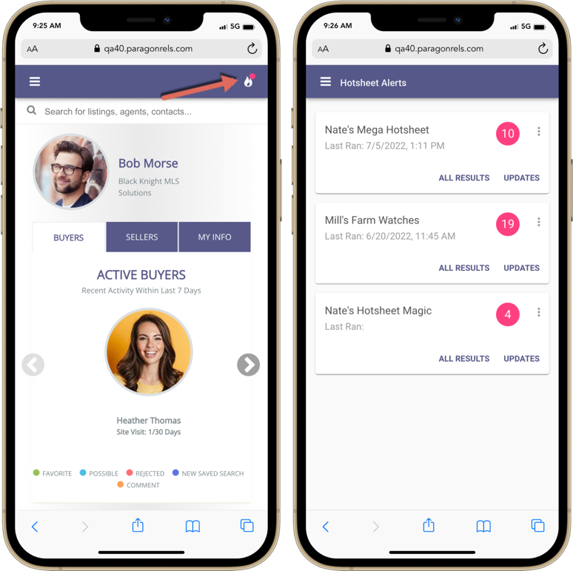
On the homepage you will notice a new fire icon on the top app bar. This monitors any updates to hotsheet searches that have alerts.
You will see a pink badge appear above the fire icon when there are new updates. Tapping on the icon will take you to the Hotsheet Alerts page where you will see all your saved alerts.
A pink circle with a count will display on any saved alert card when new updates are found. This number represents how many updates have been found. You will also notice two links at the bottom of each card.
Note: Alerts are not emailed or sent outside of Paragon Connect at this time. Will be updated to include notifications in a future release.

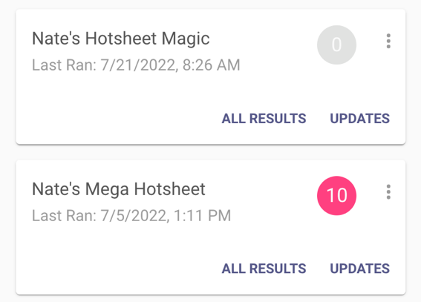
All Results:
This will take you to a thumbnail result of all hotsheet records found with this saved Hotsheet.
Updates:
This will take you the thumbnail results but will only show the new hotsheet records since this was last ran.
Once you have viewed your updates the circle count goes to zero and changes to gray. This indicates there are no new updates since this Hotsheet was last ran.

Overflow:
The overflow icon next to the alert count provides you with the ability to edit hotsheet search, remove alert, and delete the hotsheet search completely.

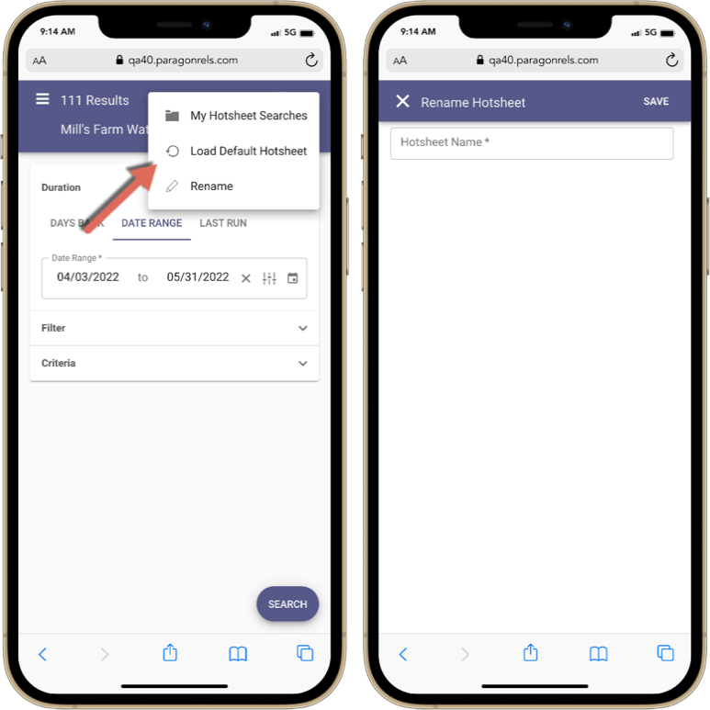
- Load default Hotsheet
While on a loaded Hotsheet search, the overflow menu will contain different options. One of those options is the “Load Default Hotsheet.” This will allow you to revert the Hotsheet back to the default Hotsheet search. This option only appears while you are on a saved Hotsheet search.

- Rename Hotsheets
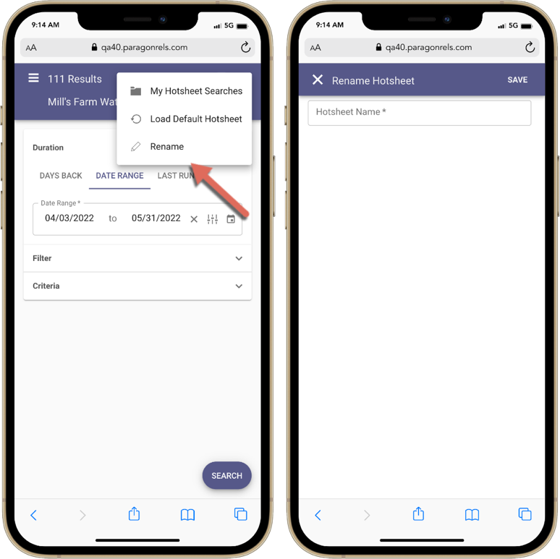
Another option that only appears while on a loaded Hotsheet search is the “Rename” option. This will allow you to rename any saved Hotsheet that you created.

- Search Hotsheets
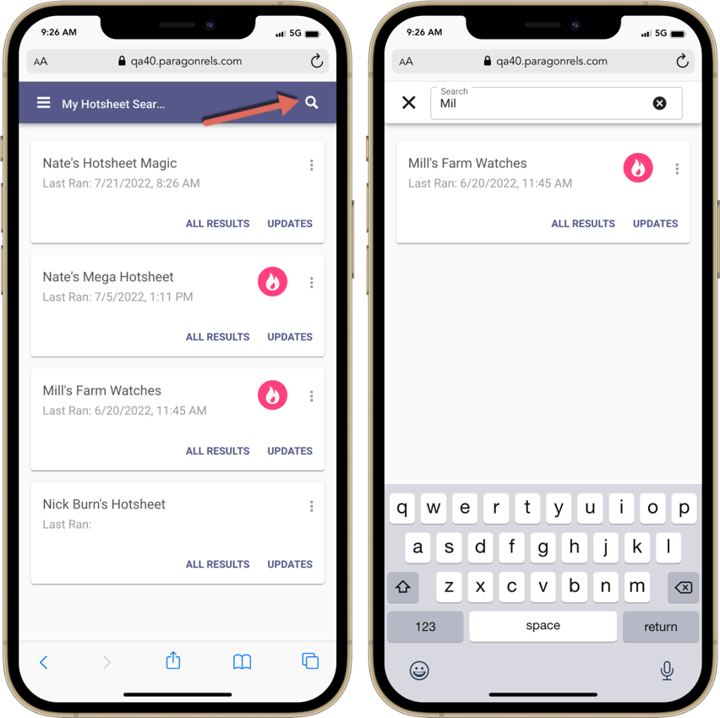
The last highlighted feature for Hotsheet is the search option. When you attempt to load a Hotsheet search, you will notice a search icon on the top app bar. This search feature allows you to quickly find any Hotsheet search you created.

- New Listing Detail Report
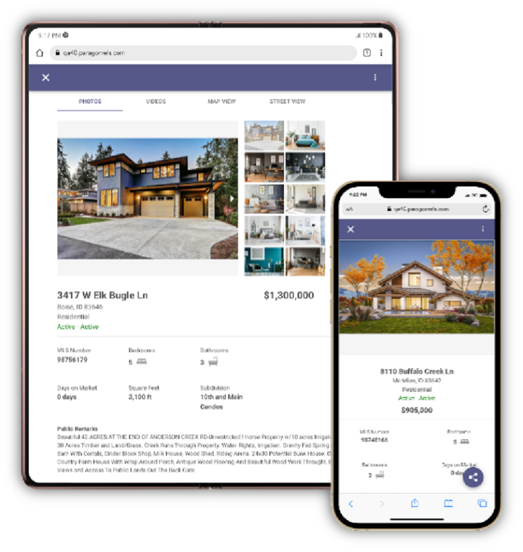
The new high performing detail report has replaced the old Paragon Connect detail report throughout the following areas in Paragon Connect.

Property Class Search
- My Location Search
- Open House Search
- Hotsheet Search
- Power Search
- Single bubble count on active buyer on the dashboard
- Seller’s tab on dashboard
- Comments on dashboard
- My Info Page
- My Listing Carts

Note: The new version of the Connect View report will not be updated in Paragon Professional until the 5.91 release.

- Open House Creation/Management Feature
This 5.90 release allows the agent to easily create and manage open houses from the Listing Input Module (LIM) on any device. Below are all the features of the Open House.

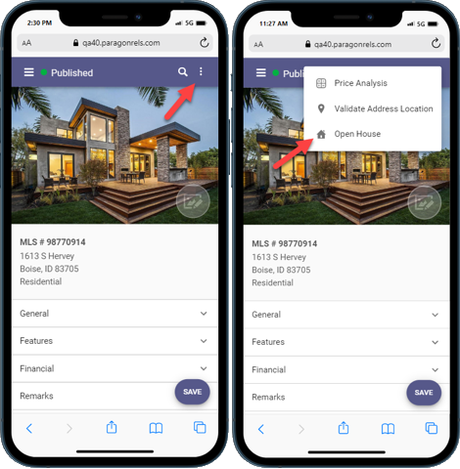
Accessing the Menu:
The open house feature can be accessed by clicking the overflow icon on the LIM listing edit screen. Clicking the Open House link will take you to the open house screen.

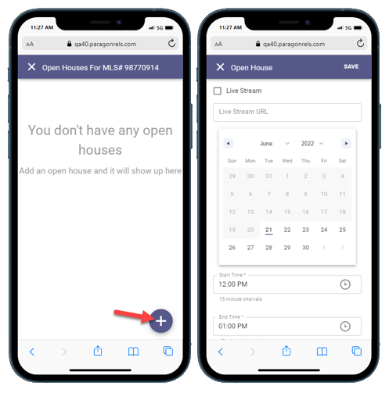

Creating an Open House:
To create an open house, click on the plus sign icon. This will take you to the open house creation screen.

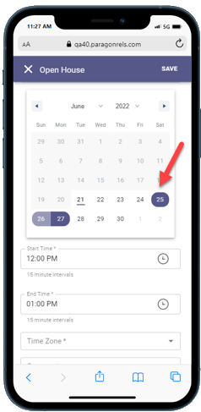
Enter the Date:
The open house date can be entered through our calendar component. Clicking a day on the calendar will select that date. The agent also has the option to create multiple open houses using a date range. The date is a required field.

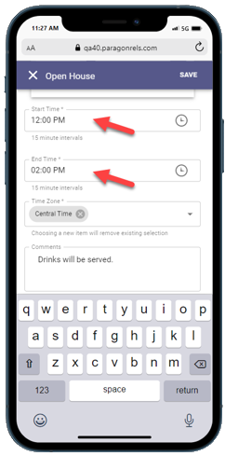

Enter Start & End Time:
You can also enter the start & end time for the open house by clicking the appropriate fields. Clicking a time field will open our time entry component. The start and end times are required fields.

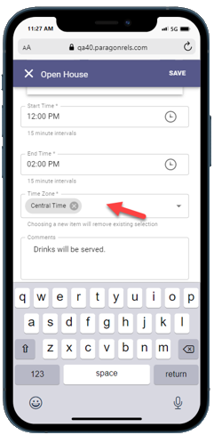

Add the Time Zone:
You must enter the time zone by clicking this field and selecting the appropriate time zone from the list. The time zone is a required field.

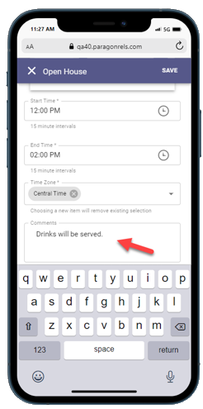
Adding in Open House Comments:
You must enter the time zone by clicking this field and selecting the appropriate time zone from the list. The time zone is a required field.

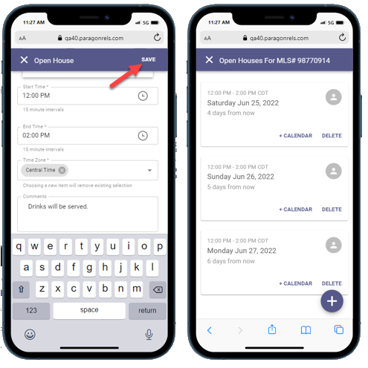
Saving an Open House:
Clicking the Save icon will check to see if all required fields are completed before saving the open house information. You will then be directed to the open house management page.

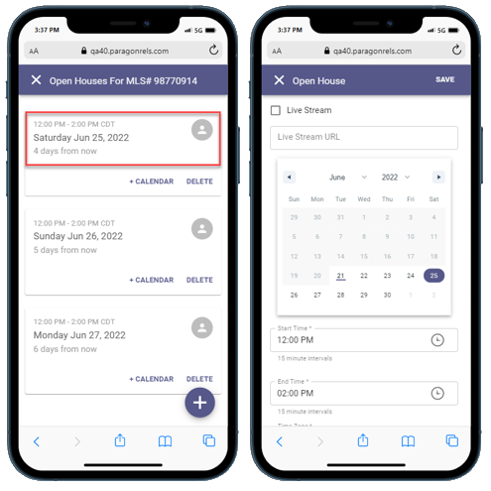
Editing an Existing Open House:
By clicking the top section of an existing open house card on the open house management page the agent can edit the open house information.
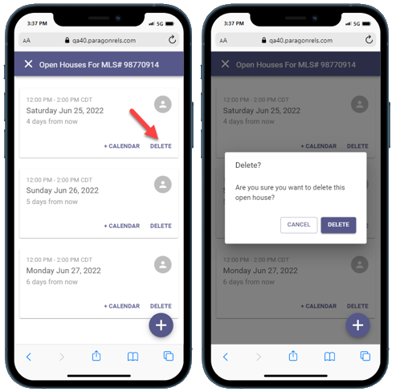
Deleting an Open House:
You can delete an open house by clicking the DELETE icon on the open house management page. It will prompt you to make sure you want to delete this open house.

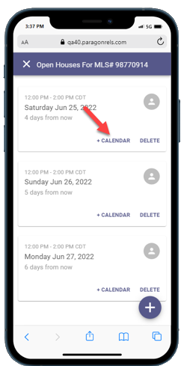

Adding to your Device Calendar:
You can add an existing open house to your device default calendar by clicking the + Calendar button and saving it to your calendar.

- Listing Maintenance Module
This release includes the beginning work for a new Listing Maintenance module within Paragon Connect. This new feature will provide a place to access all the published and unpublished listings you have permission to maintain. It will also provide a way to start a new listing.

Below is a summary of the current functionality included in this release. Additional features like Auto-tax fill and Cloning will be available in future releases.

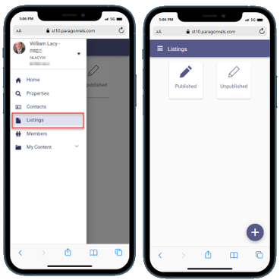
Listing Menu:
The hamburger menu includes a new option called “Listings.” This option appears to you if you have listing maintenance permissions. The new listings page allows you to select to view all your Published listings. There is an optional system setting to include Unpublished listings.

Unpublished listings are draft listings known as “Partials” within Paragon Professional. In Paragon Connect we are adopting new labels to distinguish between completed and uncompleted listings more easily

Published Listings:
Selecting published listings provides a thumbnail view of all listings where you have ownership rights. Selecting any listing will open the edit listing form where you can modify any fields and perform additional maintenance actions.

The filter option in the top menu allows you to quickly modify the listings by Status, Listing Owner, or Class.

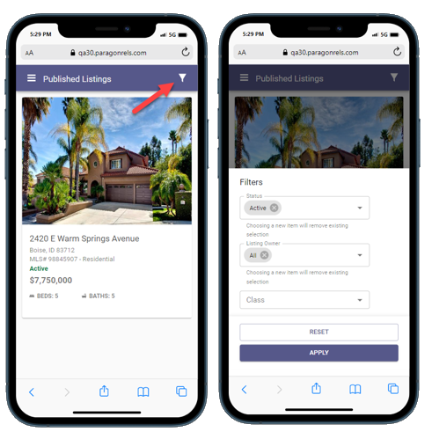

Unpublished Listings:
New name, same functionality. Paragon Professional calls them partials, we gave them a new name of unpublished. Unpublished listings are listings that do not have the details required to be a published, live listing. You may choose to edit your unpublished listings, completing the form at your convenience, until all the required fields are populated. Once the fields are complete, you may save it as a fully published listing. All field requirements and business rules applied in Paragon Professional are applied in Paragon Connect.

Please Note: If your association/MLS has turned this feature on, you will be able to use this function.

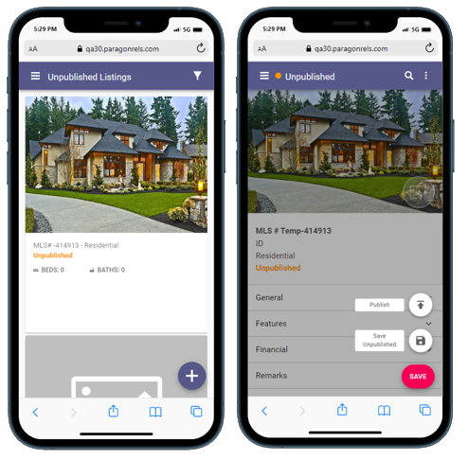

- Add a New Listing in Paragon Connect
Along with the new Listing Maintenance module within Paragon Connect there is a new option to add listings. Currently you have the ability to edit existing listings. With this new feature you have the ability to start a brand-new listing and continue to edit it until it is ready to be published as a complete, live listing.

New Listings:
You can easily start a new listing by clicking the plus sign icon, choosing the property class, then clicking CREATE. A new unpublished listing is instantly created and will be available in the unpublished list until the listing is completed and published or is automatically removed on the partial purge date. Any listing created in Paragon Connect is also available within Paragon Professional.

Please Note: If your association/MLS has turned this feature on, you will be able to use this function.

